FROELICK GALLERY For immediate release:

Solo Exhibit:
Yoshihiro Kitai
Ambivalence
June 1st – July 9th, 2022
First Thursday June 2nd 5pm – 8pm
First Saturday June 4th 1pm – 5pm
714 NW Davis St, Portland, OR 97209
info@froelickgallery.com
www.froelickgallery.com
503.222.1142

Gallery Hours: Tuesday – Saturday 11am to 5:30pm

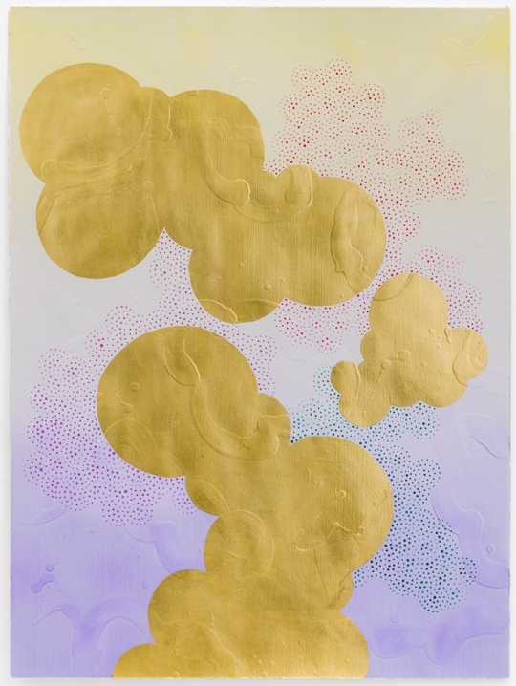
Ambivalence is Yoshihiro Kitai’s fourth solo exhibition with Froelick Gallery and includes nine works on paper and canvas. The paintings flow with colorful Gansai pigment dots, and reflective gold leaf clouds are layered on top of Kitai’s signature textured gessoed patterns.

This exhibition draws upon Kitai's ongoing observations of American life through the lens of an immigrant. Although now, Kitai has spent half of his life outside of his native Japan, he expresses the difficulty in navigating what he believes are cultural norms.

Kitai writes about Ambivalence, “My visual work is what I observe – borderless energy that flows between groups, countries, and cultures. The cloud shapes in the sky reflect how the world is connected.” Kitai’s metallic clouds form interactions with radiating dot patterns, each single dot representing an individual person that together then become larger communities, taking the shapes of clouds themselves. The viewer seems to be observing the movement of these elements from a bird’s eye view, “...a place from a non-disruptive and fair distance.” (Kitai). These elegant examinations of societal and cultural structures ultimately pay homage to Japanese art traditions.
Conflux #17, 2022, gold leaf, Gansai paint, gesso on paper, 30 x 22

Yoshihiro Kitai has been represented by Froelick Gallery since 2016.

Kitai holds an MFA in Printmaking and Drawing from Washington University, St. Louis, MO and a BFA in Printmaking from Pacific Northwest College of Art, Portland, OR. He is currently an associate professor in the printmaking department. His works are found in collections including Nomura Bank, London; The Hallie Ford Museum of Art, Salem, OR; Oregon Health Sciences University, Portland, OR; The Multnomah County Court House, Portland, OR; The Montefiore Medical Center, The Bronx, NY.

Please contact the gallery for reproduction quality images.

